**NOTE:** First few Vicon Data will be constant since I had to start the cameras before the drone started flying and also starting drone takes a few seconds from the moment I press “Start”!!

# Tests:

1. **HoverConstantHeight**

* Hover at Z = -0.9 and X = Y = 0.

1. **HoverVariableHeight**

* Hover at different altitudes but constant X = Y = 0

1. **VariableXPosition**

* Varied X values from -1 to +1 at constant altitude.

1. **VariableYPosition**

* Varied Y from -1 to +1 at constant altitude.

# Errors/weird drone issues during test flight:

* [**HoverVariableHeight**] Cannot handle sudden large changes in height (altitude). Change from 2.5m to 1.3m caused the drone to drop from 2.5m to 1.3m, hold altitude for less than a second, then fall and crash on the ground.
* [**HoverVariableHeight**] Cannot handle low heights close to the ground. If Z is set less than approximately -0.4, drone rises to the set height then slowly falls down to the ground and stops.
* [**VariableXPosition**]Drone moved sideways, positive Y direction for a few centimeters (while Y is set fixed at 0), during takeoff and lost control for a second, then maintained stable flight at set altitude.
* [**VariableYPosition**] Drone could not handle instantaneous change from -1 to +1. Moved from Y = -1 past Y = 0 but then dropped altitude and crashed as it headed for Y = 1.

# Simulink Flight Log Info (RSData.mat column naming):

**Check this** [**image**](Flight%20Log%20data.PNG) **for details. [flight Log data.PNG]**

* rt_motor – saves the final motor commands sent to all four motors. Motor numbering as follows:

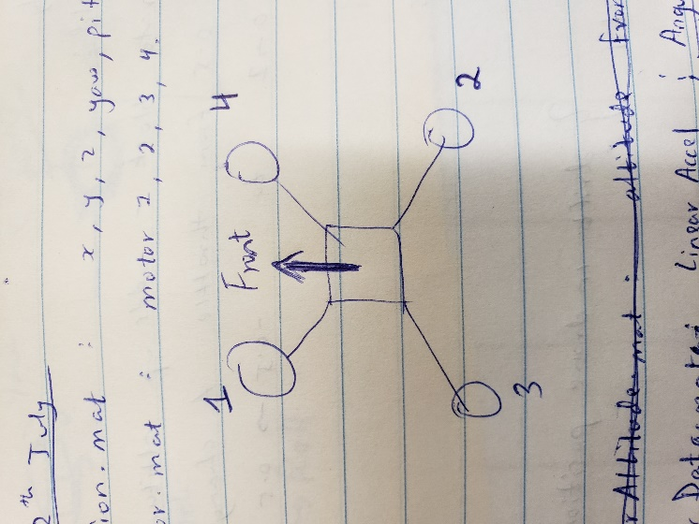

* rt_posref – saves the position reference values set as the input position reference values in order: [X, Y, Z, Yaw, Pitch, Roll]
* rt_estim – state estimator output, in order: [X, Y, Z, Yaw, Pitch, Roll, dx, dy, dz, p, q, r].

p,q,r – angular acceleration.

* rt_cmd – input commands (signal builder values).
* rt_ optical – optical sensor/ camera sensor data
* rt_calib – sensor calibration data
* rt_sensor – data measured my IMU and ultrasound sensor. In order [ddx, ddy, ddz, p, q, r, altitude, prs, battery voltage, battery percent]